Ramipril in aortic stenosis

Final report, May 2013

Lay summary

This study examined the potential for drug treatment of a condition called aortic stenosis (a narrowing of the main valve out of the heart). Patients with this condition can develop a thickened heart muscle and heart failure, both of which are detrimental. Currently, the only effective treatment is heart surgery to replace the valve, which is reserved for patients with severe aortic stenosis who are breathless. We were looking to find a drug treatment which could delay or prevent surgery, which could bring significant benefits to large numbers of people. We examined one of a group of existing drugs called ACE inhibitors, which are of proven benefit in treating both increased heart muscle thickness and heart failure from other causes. We gave this drug to half the patients in the study, with the other half receiving a blank tablet, in a randomised placebo-controlled trial format, to examine the true effects of the drug.

The study showed that the drug, ramipril, reduced the amount of heart muscle thickening progressively over the year duration of the trial. There were also trends towards improving other measures of cardiac function, but the trial may have been too small or short to demonstrate these clearly. We were also able to show that these drugs can be taken safely by patients with aortic stenosis (for other indications such as high blood pressure), despite being thought to be unsafe in the past (the evidence for harm was in fact mostly theoretical).

The results indicate a potentially positive effect of the drug and have also started to uncover the mechanisms underlying the progression to heart failure. It lays the foundation for a much larger trial to determine if the drug results in clinical benefits to patients (i.e. if we can reduce the number needing heart valve surgery, or extend the time before this is needed), which is now being planned using this data. If successful, this would be the first group of drugs to have any impact on the progression of aortic stenosis. The added benefit is that this group of drugs have been established for a long time and are inexpensive.

Background and aims

Aortic stenosis is common (~2% in the population over 65 years of age) and while many people will remain asymptomatic, some will progress to left ventricular (LV) dysfunction +/- heart failure and/or death. Valve replacement surgery is recommended when symptoms develop but LV dysfunction can occur prior to symptoms, with a reduction in prognosis post-surgery. A medical therapy to aid the myocardial response to aortic stenosis and reduce the progression to LV dysfunction would significantly aid the prognosis and management of asymptomatic patients. We believe that the response of the myocardium to aortic stenosis (in particular the hypertrophy) may be more important than the degree of stenosis, and there is good supporting evidence for this, including that LV mass is more closely related to symptoms than the degree of stenosis, and increased LV mass is strongly associated with LV dysfunction.

Angiotensin Converting Enzyme (ACE) inhibitors would seem to be an ideal group of drugs with the potential to aid patients with aortic stenosis. They are beneficial in reducing LV hypertrophy and dysfunction from other causes, and are routinely used in the treatment of hypertension and heart failure. These effects of ACE inhibitors might also be beneficial in aortic stenosis and may attenuate the progression to hypertrophy and heart failure, and potentially delay the onset of symptoms and the need for valve replacement. However, ACE inhibitors are considered to be contraindicated in patients with moderate to severe aortic stenosis, due to the theoretical danger of syncope, despite the absence of clinical data supporting this. On the contrary, animal and limited human studies suggest a beneficial effect.

ACE inhibitors thus have potential therapeutic benefits in aortic stenosis and we conducted a randomised double-blind placebo-controlled clinical trial to examine in detail the physiological effects of ACE inhibitors in aortic stenosis, in particular the changes in the myocardium using the most advanced imaging available.

Results

100 patients were recruited, and 77 completed the study with a follow-up scan at 12 months (the approximate anticipated drop-out rate). This included 41 taking ramipril, and 36 taking placebo. There were no major adverse events and no significant differences in drop-out rates between the ramipril and placebo groups, supporting the hypothesis that ACE inhibitors are not harmful in patients with aortic stenosis.

The primary outcome measure was the change in left ventricular mass. This showed a progressive beneficial effect of ramipril over the course of a year, with a small reduction in mean LV mass of 4g in the ramipril, compared to an increase of 4g in the placebo group (see graph). The changes at 6 months were half these values, suggesting a progressive and consistent change over time. Although these differences were relatively small (8g difference = ~5% of total myocardial mass in this group), they represent the mean difference, indicating an overall group change in mass, and also occurred in the presence of continued pressure overload of the ventricle from the aortic stenosis, in keeping with a direct myocardial effect of ramipril.

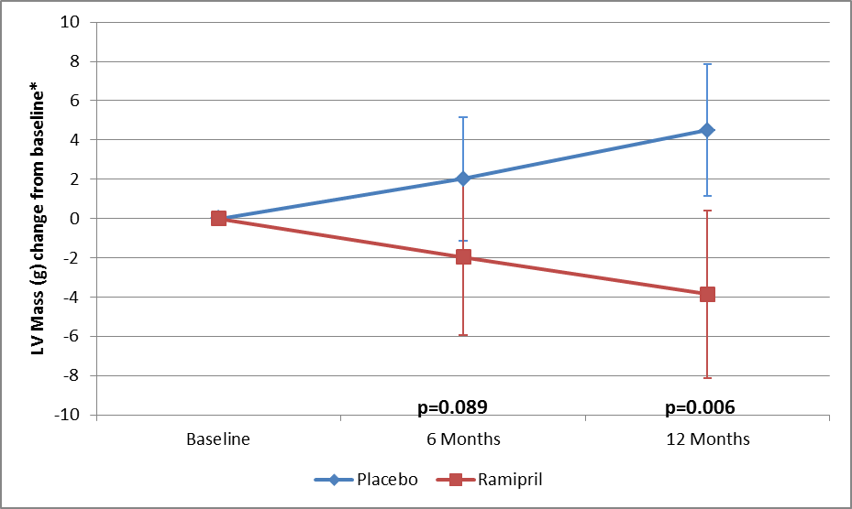
Figure 1 – Mean change in left ventricular mass over 1 year, stratified by subjects taking ramipril 10mg daily or placebo

Other myocardial parameters and exercise tolerance mostly showed little change, and no significant difference between ramipril and placebo, but there was some indication of better systolic and diastolic function with ramipril on echocardiographic parameters (change in medial S-wave placebo -0.5cm/sec, ramipril 0.0 [p=0.04]; lateral E:E’ ratio placebo +1.0, ramipril -1.6 [p=0.12]). There was also a trend towards slowing of progression in the aortic valve itself (reduction in valve area: placebo -0.2cm², ramipril 0.0 [p=0.07]).

We were also able to apply our new T1 mapping technique to these patients, and showed that we could detect differences in the myocardium between patients with severe aortic stenosis and others, which may allow better characterisation of the myocardial response to aortic stenosis in the future, and is potentially an early predictor of myocardial decompensation.

Figure 2 – Myocardial T1 maps using our new ShMOLLI technique, which demonstrated higher T1 values (greater degrees of red in the image) in the myocardium in those with severe symptomatic aortic stenosis compared to others.
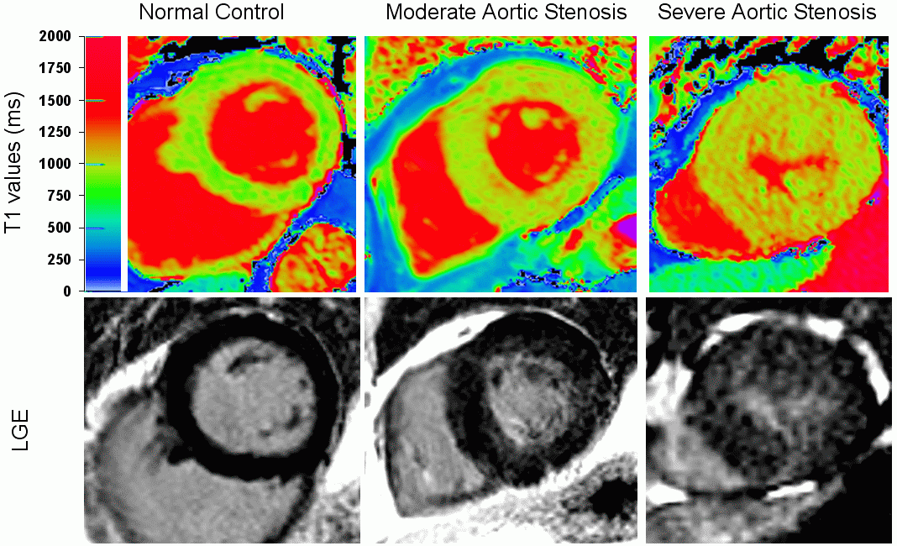

Conclusions

These results indicate that ACE inhibitors (ramipril in this case) have physiological effects on the myocardium in patients with aortic stenosis, and result in a modest group reduction in LV mass. This was despite a fixed outflow obstruction (i.e. continued pressure load on the ventricle) and suggests a direct myocardial effect. The change was progressive over one year, and longer treatment duration would likely result in greater changes. There were trends towards improvements in other physiological parameters, though the sample size and study duration were likely too small/short for greater effects. The study also showed that ACE inhibitors could be well tolerated in patients with significant aortic stenosis, despite historical fears about their safety, though this study involved only moderate numbers taking ramipril (~50).

The study forms an excellent basis for a larger multi-centre trial of a longer duration examining clinical outcomes in patients with aortic stenosis, which is now being planned. This would have the potential to really change clinical practice. It has the support of national valve research groups in both the British Cardiovascular Society and the British Society for Cardiovascular Magnetic Resonance, based on the results from this study.

Publications arising from this work

- Human non-contrast T1 values and correlation with histology in diffuse fibrosis. Bull S, White SK, Piechnik S, Flett AS, Ferreira V, Loudon M, Francis JM, Karamitsos TD, Prendergast B, Robson MD, Neubauer S, Moon JC, Myerson SG, Heart 2013 Jul; 99(13): 932-7. doi: 10.1136/heartjnl-2012-303052. Epub Jan 24 2013
- (Main RIAS study paper in preparation)

Conference presentations

Impaired myocardial perfusion in moderate asymptomatic aortic stenosis relates to longitudinal strain but not non-contrast T1 values. Sacha Bull, Stefan K Piechnik, Vanessa Ferreira, Margaret Loudon, Jane M Francis, Stefan Neubauer, Saul Myerson J Cardiovasc Magn Reson 2013; 15 (suppl 1), Society for Cardiovascular Magnetic resonance conference 31 Jan - 3 Feb 2012, San Francisco, USA
Pre-contrast T1 mapping for detection of myocardial fibrosis in asymptomatic and symptomatic aortic stenosis [abstract] Sacha Bull, Steven K White, Stefan K Piechnik, Andrew Flett, Vanessa Ferreira, Margaret Loudon, Jane M Francis, Stefan Neubauer, James Moon, Saul Myerson. J Cardiovasc Magn Reson 2012; 14 (suppl 1), P93, Society for Cardiovascular Magnetic resonance conference 2-5 Feb 2012, Orlando, USA
Sacha Bull, Joseph J Suttie, Harry Willis, Jubin Joseph, Jane M Francis, Theodoros Karamitsos, Stefan Neubauer, Saul Myerson. Circumferential strain predicts major adverse cardiac events independent of myocardial perfusion in asymptomatic aortic stenosis [abstract]. In J Cardiovasc Magn Reson 2012; 14 (suppl 1), P90, Society for Cardiovascular Magnetic resonance conference 2-5 Feb 2012, Orlando, USA
Bull S, Suttie J, Joseph J, Francis JM, Karamitsos TD, Pitcher A, Becher H, Prendergast B, Neubauer S, Myerson SG. Left ventricular strain predicts major adverse cardiac events in asymptomatic aortic stenosis In Circulation 2011; 124 (suppl 1); abstract 13410; American Heart Association 12-16 Nov 2011, Orlando, USA
Joseph J Suttie; Sairia Dass; Sacha Bull; Cameron Holloway; Rajarshi Banerjee; Pete Cox; Alex Pitcher; Belen Rial Franco; Jane Francis; Jurgen Schneider; Matthew Robson; Hugh Watkins; Saul Myerson; Stefan Neubauer. Cardiac Steatosis Detected in Hypertrophic Cardiomyopathy, Dilated Cardiomyopathy and Aortic Stenosis [abstract]. In Circulation 2011; 124 (suppl 1); abstract 17133; American Heart Association 12-16 Nov 2011, Orlando, USA
Bull S, Suttie J, Blundell N, Francis JM, Karamitsos TD, Pitcher A, D'Arcy J, Prendergast B, Neubauer S, Myerson SG. Cardiovascular magnetic resonance (CMR) tagging identifies differential ventricular remodelling in patients with bicuspid vs tricuspid aortic valve disease [abstract]. In Heart 2011; 97 (suppl 1); British Cardiovascular Society 13-15 June 2011, Manchester, UK. Page A92-93, abstract no. 166
Bull S, Pitcher A, Augustine D, D'Arcy J, Francis JM, Karamitsos TD, Bin Sultan Rai A, Prendergast B, Becher H, Neubauer S, Myerson S. The elusive bicuspid valve: factors that contribute to correct identification of valve morphology in clinical practice [abstract]. In EHJ Cardiovascular Imaging 2011; 12 (suppl 2); EuroEcho conference 7-9 Dec 2011, Budapest, Hungary. Page ; Abstract P680
Bull S, Suttie J, Augustine D, D'Arcy J, Francis JM, Karamitsos TD, Becher H, Prendergast B, Neubauer S, Myerson S. Gender differences in fibrosis and torsion in the heart with aortic stenosis [abstract]. In EHJ Cardiovascular Imaging 2011; 12 (suppl 2); EuroEcho conference 7-9 Dec 2011, Budapest, Hungary. Page ii68; Abstract P972
Bull S, Pitcher A, Francis JM, Suttie J, Joseph J, D'Arcy J, Prendergast B, Becher H, Karamitsos TD, Neubauer S, Myerson SG. CMR improves identification of aortic valve morphology in aortic stenosis [abstract]. In J Cardiovasc Magn Reson 2011; 13 (suppl 1), Society for Cardiovascular Magnetic resonance/EuroCMR conference 3-6 Feb 2011, Nice, France. Page 309; abstract P332

